National University of Computer and Emerging Sciences



Laboratory Manuals

for

Database Systems Lab
(CL -2005)

Course Instructor | Ms. Aleena Ahmad
Lab Instructor | Muhammad Kamran
Lab TA | Abdullah Naeem
Section | BCS-4F
Semester | Spring 2025

Department of Computer Science
FAST-NU, Lahore, Pakistan
Lab Manual 03

SQL
SQL tutorial gives unique learning on Structured Query Language and it helps to make practice on SQL commands which provides immediate results. SQL is a language of database, it includes database creation, deletion, fetching rows and modifying rows etc. SQL is an ANSI (American National Standards Institute) standard, but there are many different versions of the SQL language.
Why SQL?
- Allows users to access data in relational database management systems.
- Allows users to describe the data.
- Allows users to define the data in the database and manipulate that data.
- Allows embedding within other languages using SQL modules, libraries & pre-compilers.
- Allows users to create and drop databases and tables.
- Allows users to create views, stored procedure, functions in a database.
- Allows users to set permissions on tables, procedures and views
SQL Process
When you are executing an SQL command for any RDBMS, the system determines the best way to carry out your request and SQL engine figures out how to interpret the task.
There are various components included in the process. These components are Query Dispatcher, Optimization Engines, Classic Query Engine and SQL Query Engine, etc. Classic query engine handles all non-SQL queries, but SQL query engine won't handle logical files.
Following is a simple diagram showing SQL Architecture:
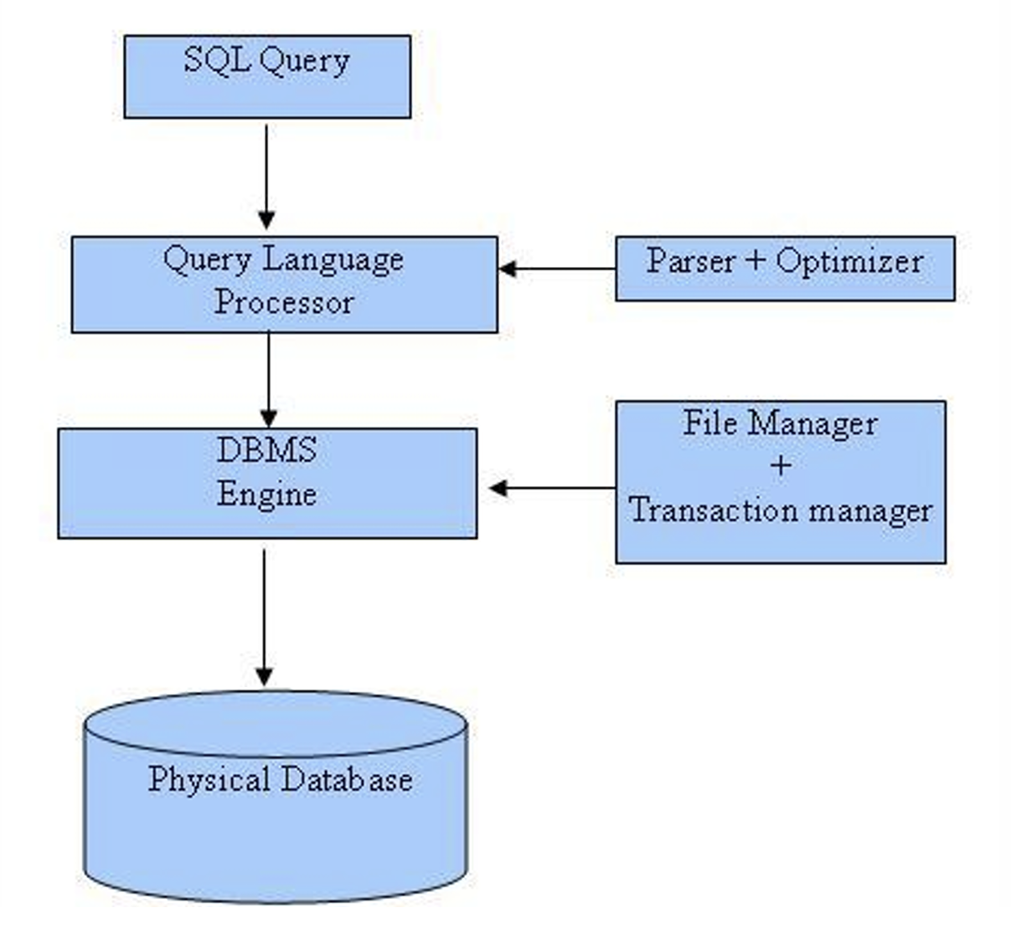
SQL Commands
In previous manual we covered DDL & DML, in this manual we’ll cover DQL
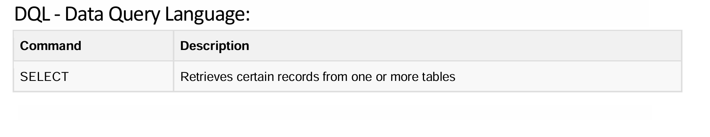

Overview of DQL

1. Basic SELECT, FROM, and WHERE Clauses

Concept
- SELECT: Specifies the columns you want to retrieve.
- FROM: Specifies the table from which to retrieve the data.
- WHERE: Filters the rows based on a given condition.

Syntax
SELECT column1, column2, ...
FROM TableName
WHERE condition;

Scenario Example
Imagine you have an Employees table and you want to retrieve the names and departments of employees whose salary is greater than 50,000:
SELECT EmployeeName, Department
FROM Employees
WHERE Salary > 50000;

2. Ordering Results with ORDER BY

Concept
The ORDER BY clause sorts the result set by one or more columns. You can specify ascending (ASC) or descending (DESC) order.

Syntax
SELECT column1, column2, ...
FROM TableName
WHERE condition
ORDER BY column1 [ASC|DESC];

Scenario Example
For a Products table, to list all products with a price greater than 20, ordered by price in ascending order:
SELECT ProductName, Price
FROM Products
WHERE Price > 20
ORDER BY Price ASC;

3. Arithmetic Operations in SELECT

Concept
You can perform arithmetic calculations directly in your SQL queries. This is useful for computing derived values, such as discounts or totals.

Syntax
SELECT column1,
(column2 * 0.1) AS Discount, -- calculates 10% of column2
(column2 - (column2 * 0.1)) AS FinalPrice
FROM TableName;

Scenario Example
For a Products table, to calculate a 10% discount and final price for each product:
SELECT ProductName,
Price,
(Price * 0.1) AS Discount,
(Price - (Price * 0.1)) AS FinalPrice
FROM Products;

4. String Functions and Substring Operations

Concept
SQL provides functions to manipulate and analyze text. Common functions include:
- SUBSTRING(): Extracts a portion of a string.
- LENGTH(): Returns the number of characters in a string.
- UPPER() / LOWER(): Converts text to uppercase or lowercase.

Syntax for SUBSTRING and LENGTH

SELECT column1,
SUBSTRING(column1, start, length) AS SubText,
LENGTH(column1) AS TextLength
FROM TableName;

Scenario Example
For a Customers table, extract the first 3 characters of each customer’s name and display its length:

SELECT CustomerName,
SUBSTRING(CustomerName, 1, 3) AS Initials,
LENGTH(CustomerName) AS NameLength
FROM Customers;

5. Comparison Operators

Concept
Comparison operators are used in the WHERE clause to filter records based on numeric, date, or string comparisons. Common operators include:
- = (equal)
- <> or != (not equal)
- > (greater than)
- < (less than)
- >= (greater than or equal to)
- <= (less than or equal to)
- LIKE (pattern matching)

Syntax

SELECT *
FROM TableName
WHERE column1 = 'Value';

Scenario Example
For an Employees table, retrieve records for employees whose department is 'Sales':
SELECT EmployeeName, Department
FROM Employees
WHERE Department = 'Sales';

For pattern matching (e.g., names starting with "A"):
SELECT EmployeeName
FROM Employees
WHERE EmployeeName LIKE 'A%';

6. Set Operations

Concept
Set operations allow you to combine the results of two or more SELECT queries. They include:
- UNION: Combines results and removes duplicates.
- UNION ALL: Combines results and retains duplicates.
- INTERSECT: Returns only the rows common to both queries.
- EXCEPT: Returns rows from the first query that are not in the second.

Syntax for UNION

SELECT column1 FROM TableA
UNION
SELECT column1 FROM TableB;

Scenario Example
Suppose you have two tables, CurrentCustomers and PastCustomers, and you want a list of all unique customer names:
SELECT CustomerName FROM CurrentCustomers
UNION
SELECT CustomerName FROM PastCustomers;

For INTERSECT (if supported by your SQL dialect) to find common customer names:
SELECT CustomerName FROM CurrentCustomers
INTERSECT
SELECT CustomerName FROM PastCustomers;

For EXCEPT to find names in CurrentCustomers that are not in PastCustomers:

SELECT CustomerName FROM CurrentCustomers
EXCEPT
SELECT CustomerName FROM PastCustomers;

7. Additional Scenario Examples Using Combined Concepts

Scenario: Sales Analysis
Imagine a Sales table where you want to analyze revenue:
- Calculate total revenue: Use arithmetic operations.
- Filter for high-revenue transactions: Use WHERE and comparison operators.
- Order by transaction date: Use ORDER BY.

SELECT TransactionID,
(Quantity * Price) AS Revenue,
TransactionDate
FROM Sales
WHERE (Quantity * Price) > 1000
ORDER BY TransactionDate ASC;

Scenario: Employee Performance
For an Employees table:
- Compute performance score: Combine arithmetic and string functions.
- Filter for employees in a specific department.
- Order by performance score descending.
SELECT EmployeeName,
Department,
(Salary / LENGTH(EmployeeName)) AS PerformanceScore
FROM Employees
WHERE Department = 'Engineering'
ORDER BY PerformanceScore DESC;

In this tutorial, we covered:
- Basic SELECT–FROM–WHERE: Retrieving specific columns and filtering rows.
- ORDER BY: Sorting your results.
- Arithmetic Operations: Performing calculations in your queries.
- String Functions: Extracting and analyzing text.
- Comparison Operators: Filtering records based on various conditions.
- Set Operations: Combining results from multiple queries.
Each concept was illustrated with generic syntax and scenario examples that you can adapt to various contexts. By mastering these fundamental elements, you’ll be well-equipped to tackle more advanced SQL queries in any domain.

Happy learning and querying!


Download lab-3 sql file provided with this manual. Run that file and a schema with following details will be created:
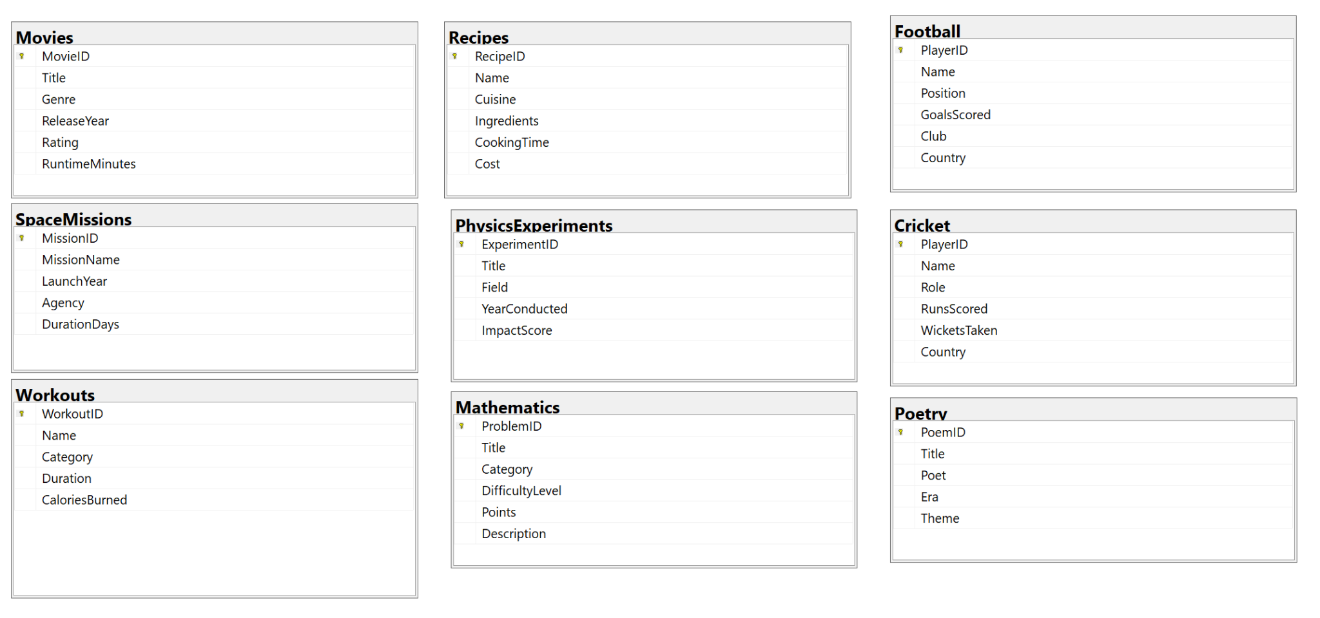


In Lab Exercises

Write following queries in a SQL file and submit
- Retrieve all Sci-Fi movies released after 2010, ordered by rating.
- Find all recipes that take less than 30 minutes to cook.
- List players with more than 400 goals but less than 700 goals, along with their position and club.
- Find the average runs scored by batsmen and the total wickets taken by bowlers.

- Retrieve the names of missions lasting over 1000 days or launched before 1980.
- List all cardio workouts where the calories burned are greater than the average of all workouts.
- Doraemon wants to watch a movie with a rating higher than 8.5, released after 2010, but prefers to avoid genres that Nobita dislikes: Action and Thriller.
- Doraemon and Nobita are planning a trip to space. They want to prioritize missions lasting more than 1000 days but avoid missions launched by NASA in the 20th century.
- Doraemon needs healthy meals for their space trip. He wants recipes that take less than 30 minutes to prepare and use “Eggs” as an ingredient. Order the results by cooking time.
- Nobita needs to stay fit for the journey. Find workouts categorized as Cardio or Strength where calories burned exceed 250 but take less than the average duration of all workouts.
- Doraemon is inspired by classical poetry and wants to compile an anthology. Find poets who wrote about themes of Love or Imagination in the Romantic or Mystical eras. Include their poem titles and themes in the result.
- Nobita is trying to calculate the total duration of all space missions (in years and days). Use arithmetic operations to create a combined output in the format X years and Y days.
- Nobita wants to train for space travel. Find workouts where the calories burned are at least 30% of the average calories burned during all space missions.

Extra Exercises & Project Practice

- Doraemon is planning a timeline for Nobita's adventure, including the following events:
- Movies watched (sorted by release year).
- Cricket matches played (sorted by match date).
- Space missions launched (sorted by launch year).
Combine all these events into a single timeline using set operations.
2. Connect to SQL Server using connection string from NodeJS
3. Write NodeJS endpoints to retrieve data from database. For example, /sci-fi to get all scifi movies and /sci-fi?after=2010 to get all scifi movies after 2010

Submission Guidelines

- submit following files strictly following the naming convention
  - l231234.sql

Best of Luck! Happy Querying

